Research and production firm "META"

Measuring parameters of light of headlights
МOTOR VEHICLES
ИПФ-01
PASSPORT
M PS 048.000.00.00-02

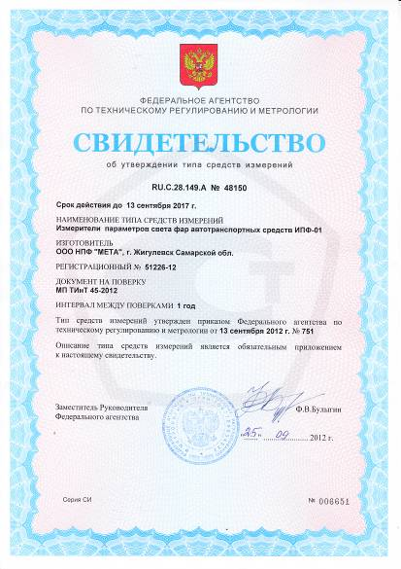

1 GENERAL INFORMATION DEVICE AND TECHNICAL SPECIFICATIONS
1.1 Meter parameters headlights of vehicles IAP-01 (hereinafter - the device) is used for maintenance checks and adjustments of external lighting of vehicles in accordance with the requirements of GOST R 51709-2001 "Road vehicles. Hardware requirements and methods of test "ism. Number 1.
The device allows the following measurements:
- Measurement of angles of inclination of the beam car headlights;
- Measurement of luminous intensity of external lighting devices;
- Measurement of the time from the direction indicators before the first glimpse;
- Measurement of the repetition frequency of flashes indicators;
The device can connect to the diagnostic line during the comprehensive technical inspection of the vehicle to transmit the measured characteristics of the personal computer.
It can be used on the road in specially selected sites or sections of roads, with asphalt or cement concrete pavement, as well as in hospital fleets and owners of private cars.
The manufacturer - NPF "META"
Mailing address:
445359, Samara, town of Zhigulevsk, Radiozavodskaya Street 1, p / 25,
Tel: (84862) 2-18-55, 2-39-48
1.2 Main characteristics
the main technical characteristics are given in Table 1
Table 1
Characteristic | property values
Measurement range of angles of inclination the cut-off beam lights in a vertical plane | 2°20'
Maximum permissible absolute error of measurement angles of inclination cut-beam headlamps in a vertical plane | ±0,1%
Limit of permissible absolute error of optical measuring chamber in a horizontal plane | ±30'
Measurement range of luminous intensity of external light sources | from 200 till 125000 кд
Limits of relative error of measurement of luminous intensity of external light sources | ±15%
Other optical aperture of the objective | 233х170 мм
Measuring range of the repetition frequency of the light flashes indicator lamps | from 1 till 2 Гц
Maximum permissible absolute error of measurement repetition frequency of light flashes indicator lamps | ±0,1 Гц
Lift height measuring unit | from 250 till1600 мм
Operating Temperature Range | From minus 10 till  +40 °С
supply voltage  - DC  - Built-in rechargeable battery | (10÷14) В  (3,5÷4) В
Weight, not more | 20 kg
Overall dimensions, | (1830×600×  590) мм

PACKAGE 2
2.1 Scope of the apparatus corresponds to Table 2.
Table 2
name | designation | amount | note
measuring unit | М 048.100.00.00-02 | 1
telescopic viewfinder | М 048.105.00.00 Б | 1
rack | М 048.203.00.00 | 1
trolley | М 048.202.00.00 Б | 1
external photodetector | М 048.200.00.00 | 1
Cable charging  Cigarette |  | 1
charger | SYB-L3S10M (12,6 В) | 1 | With the socket on the cable DJK-10C
Cover to the measuring unit | М 048.955.00 | 1 | on order
A transit box for measuring unit |  | 1
A transit box rack |  | 1
A transit box for truck |  | 1
passport | М 048.000.00.00-02 ПС | 1
Instruction manual | М 048.000.00.00-02 РЭ | 1
verification procedure | МП ТИнТ 45-2012 | 1

Note - additional request can be supplied rails Trolley IAP-01.
3 Resources, life and STORAGE, AND Producer (supplier)
The average life of the appliance for at least 6 years if the consumer requirements of the current operational documentation.
3.1 WARRANTY (supplier)
3.1.1 The manufacturer guarantees that the gauge parameters headlights of vehicles "ИПФ-01" to the technical requirements and design documentation in compliance with the rules of transportation, storage and use.
3.1.2 The warranty period is 12 months from the date of sale.
3.1.3. During the warranty period, the manufacturer is free repair or replace the unit for a warranty card.
Repair devices for post-warranty period shall be the manufacturer with the payment by the consumer.
4 CERTIFICATE OF PACKAGING
Measuring parameters headlights of vehicles "ИПФ-01" M 048.000.00.00-02 № ______________
Packed _______________________________________________
manufacturer's name or code
according to the requirements of the technical documentation.
_____________________________________________________
post personal signature name
____________________________
year, month, day

5 CERTIFICATE OF ACCEPTANCE
Measuring parameters headlights of vehicles "ИПФ-01" M 048.000.00.00-02 serial number __________ made ​​and accepted in accordance with the mandatory requirements of the state standards, the current technical documentation and is fit for service.
The representative of the TCI
MP_______________ _______________
personal signature name
_______________
year, month, day
6 NOTES FOR USE AND STORAGE
6.1 The instrument can be transported in a transport container all types of covered ground and water vehicles (railcars, containers, closed vehicles, holds, etc.) in accordance with the shipping rules in force in each mode of transport.
Transportation conditions - Group 7, GOST 15150 - 69;
6.2 Devices in packing company - the manufacturer should be stored in the warehouses of the supplier and the consumer in storage group I in accordance with GOST 15150 - 69 with the restriction on the effects of low temperatures down to minus 30 ° C.
7 INFORMATION ON COMPLAINTS
7.1 In the event of failure or malfunction of the device during the period of its warranty obligations, and to detect incompleteness in its initial acceptance of the owner of the device should be sent to the manufacturer or to the enterprise, provides coverage for the following documents:
- A request for repair (replacement);
- Punch list;
- Warranty card.
In the punch list shall specify the device model, date of manufacture, date of purchase and serial number of the device and the nature of the problem and the name of the enterprise, consumer, address and telephone number.
The address of the manufacturer: NPF "META"
445359 Samara. Town of Zhigulevsk, Radiozavodskaya street 1, p / 25,
tel / fax (84862) 2-18-55, 2-39-48

TABLE VERIFICATION
Measuring parameters headlights of vehicles
"IAP-01"
Number of the device | Date of calibration | conclusion  (pass, fail) | Verification officer (signature, stamp impression)

The manufacturer - NPF "META"
Mailing address:
445359, Samara region, Town of Zhigulovsk, street Radiozavodskaya 1, p / 25,
Tel: (84862) 2-18-55, 2-39-48
Warranty Card
for repair (replacement) during the warranty period
Product: Measuring parameters headlights of vehicles "ИПФ-01"
__________TU 4432100-048-21298618-2012__________________ number TU
Number and date of issue___________________________________
filled by the manufacturer
Purchased___________________________________________
date, signature and stamp of the selling organization
Permission for use __________________________________
date and signature
Accepted for warranty repair company
_____OOO NPF "META" _____town of Zhigulovsk_________
Signature and seal of the head repair facility
Signature and seal of the head of establishment owner

