SCIENTIFIC - PRODUCTION COMPANY "META"

Measuring parameters of headlights
MOTOR VEHICLES
IAP (ИПФ) – 01

OPERATION MANUAL
М 048.000.00.00-02 РЭ

М 048.000.00.00-02 РЭ

2

CONTENTS
INTRODUCTION 5
1 DESCRIPTION AND OPERATION 5
1.1 Description and operation of the device 5
1.1.1 Appointment 5
1.1.2 Technical Specifications 6
1.1.3 Composition of the device 7
1.1.4 Design and operation 7
1.1.5 Identification mark and sealing 16
1.1.6 Packing 16
2 Intended Use 17
2.1 Operational restrictions 17
2.2 Preparation of the device for use 17
2.3 Installation of the device and its orientation of a relative vehicle 18
2.4 Use of the device 20
3 MAINTENANCE OPERATION 30
3.1 Maintenance operation of the device 30
3.2 Maintenance 31
4 STORAGE 33
5 TRANSPORTATION 33
Appendix A. Checking technique

3

4

The present maintenance manual is intended for studying of the device and mode of functioning of a measuring instrument of parameters of headlights of IPF-01 vehicles, and also contains the data necessary for its correct operation and service.

1 DESCRIPTION AND OPERATION
  - Description and operation of the device

1.1.1 Appointment
The measuring instrument of parameters of headlights of IPF-01 vehicles (further in the text - device) is intended for check of a technical condition and resetting of external light devices of vehicles according to GOST P 51709-2001 requirements "Vehicles. Requirements to a technical condition and check methods" amendment No. 1.
The device allows carrying out the following measurements:
- measure angles of inclination on the beam car headlights
- measurement of luminous intensity of external light devices
- measurement repetition rate flashes indicators
The device can be connected to the diagnostic line at carrying out complex technical inspection of a condition of cars with possibility of drive measured characteristics in the personal computer.
The device can be used in road conditions on specially chosen platforms or sites of highways; having an asphalt or cement and concrete carpet, and also in stationary conditions of motor transport services and owners of private cars.
Type of a climatic modification - UHL4 in accordance with GOST 15150-69 with the following restrictions:
- ambient temperature from a minus 10 to plus of 40 wasps at works by definition and resetting of the light stream direction, on measurement of light force and temporary parameters of breakers gleams of turning movement;
- relative moistness to 100 % at temperature of 25 wasps
- Atmospheric pressure of 73-106 кПа (550-800 mm of mercury.).
Current supply of the device can be carried out:
- From the accumulator (or the lighter) a checked vehicle. Connection to the battery or cigarette lighter socket is made using the cable which is supplied.
- from own accumulator battery tension of 3,7 W

1.1.2 Technical Specifications

The main technical characteristics of the device are given in table 1
Table 1
name of characteristics | value of characteristics
Range of measurements discharge angles of light-to-dark border of a light bunch in the vertical plane | 2°20'
Maximum permissible absolute error of measurement angles of inclination cut-beam headlamps in a vertical plane | ±0,1%
Limit of permissible absolute error of optical measuring chamber in a horizontal plane | ±30'
Measurement range of luminous intensity of external light sources | from 200 to 125000 кд
Limits of relative error of measurement of luminous intensity of external light sources | ±15%
Other optical aperture of the objective of measuring uni | 233х170 мм
Measuring range of the repetition frequency of the light flashes indicator lamps | from 1 to2 Гц
Maximum permissible absolute error of measurement repetition frequency of light flashes indicator lamps | ±0,1 Гц
Height of lifting of the measuring block | from 250 to1600 мм
Range of working temperatures | From minus 10 to  +40 °С
Source voltage  - from a source of direct current  - from the built-in accumulator battery | (10÷14) В  (3,5÷4) В
Weight, no more | 20 кг
Outline dimensions, no more | (1830×600×590) мм
Average time between failures, not less | 8000 hours
Average life cycle, not less | 6 years

1.1.3 Composition of the device
1.1.3.1 The set of delivery of the device is given in table 2.
Table 2
Name | designation | amount | note
measuring unit | М 048.100.00.00-02 | 1
telescopic viewfinder | М 048.105.00.00 Б | 1
rack | М 048.203.00.00 | 1
trolley | М 048.202.00.00 Б | 1
external photodetector | М 048.200.00.00 | 1
Charger cable from the cigarette lighter |  | 1
charger | SYB-L3S10M (12,6 В) | 1 | With the cable outlet DJK-10C
Cover to the measuring unit | М 048.955.00 | 1 | on order
A transit box for measuring unit |  | 1
A transit box rack |  | 1
A transit box for truck |  | 1
passport | М 048.000.00.00-02 ПС | 1
Instruction manual | М 048.000.00.00-02 РЭ | 1
verification procedure | МП ТИнТ 45-2012 | 1
Note - additional request can be supplied rails Trolley ИПФ-01.
1.1.4 Structure and function
1.1.4.1 Operation
Functional diagram of the measuring unit unit shown in Figure 1.

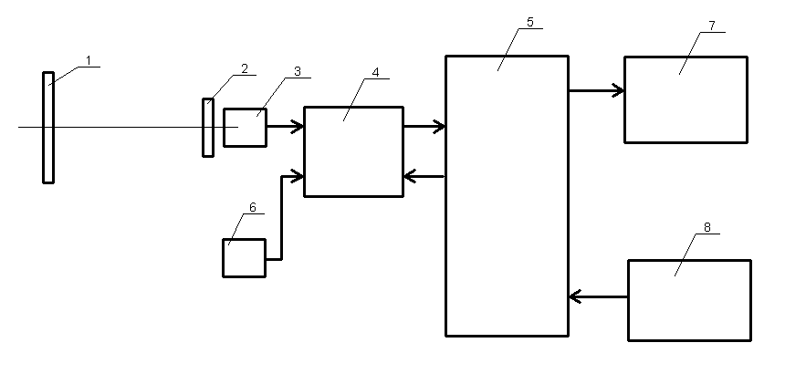
1 - Fresnel lens, 2 - Light filter, 3 - Photodiode 4 - Managed amplifier photodiode 5 - Electronic PCB control and indication 6 - External photo detector;
7 - Two-line display, 8 - Control buttons.
Figure 1 - Block diagram of the sensor
Light from the lamp passes through a verifiable Fresnel lens 1, filter 2 and 3 hits the photodiode. Electric current photodiode proportional to the force of light enhanced control amplifier 4 and enters the microprocessor located on the electronic control board and display 5. The analog signal is converted to digital form, and on the basis of these data the microprocessor calculates the power of light. The result and other service messages are displayed in a two-line display 7. To measure the frequency of the flashing turn indicators vehicle using an external photo detector 6, an electrical signal is amplified and controlled amplifier 4 is also supplied to the microprocessor, located on the electronic control board and display 5. Blink rate and other indicators flashing characteristics are calculated by microprocessor and displayed on a two meter 7. Control of the device is made using the control buttons 8.
1.1.4.2 The design of the device
The design of the device in operation is shown in Figures 2 - 8.
The instrument consists of:
- The measuring unit;
- Front;
- An optical viewfinder system orientation of the device;
- External detector;
- Trolley.
Meter (Fig. 2, Item 3) is movable by means of a rack guide bushings. For orientation relative to the measuring unit rack and secure it at a given height is the mechanism for locking the flywheel.
Composition of the measuring unit:
- The screen;
- A mechanism for moving the screen to the flywheel;
- Limb;
- Base;
- Fresnel lens in a frame;
- Housing with window;
- The electronic control board and display;
- Detector with filters placed on the screen and attached to the additional circuit board;
- Control Panel;
- Panel with connectors for power supply, external photo detector and the line diagnostic monitoring (LTC).
Screen (Figure 4) is moved in a vertical direction through the mechanism provided with a hand wheel on the side of the housing.
Position of the screen corresponds to the scale of the dial settings on the rear wall of the measuring unit.
Based on the measuring unit (bottom) openings for calibration (Fig. 3).
Stand (Fig. 2, item 2) is made of a thin-walled rectangular tube. Mounted on the side of the tonnage range, at the top of the rack is sight for orientation of the device relative to the object. Front mounted on a platform truck, secured with 4 screws. Viewfinder systems orientation of the device (Fig. 7) is in the form of pipe with the sighting groove and arranged side by wire, acting as a line of sight, with the ability to move the rack up and down, followed by fixing in position. Positions of the target to match the line viewfinder with horizontal lines on the screen are the adjustment screws.
Trolley (Figure 2, item 4) light type has three wheels (or roller). On the trolley is a playground for the installation and mounting rack. The wheels are mounted on an axis with the eccentric, with the help of which the possibility of height adjustment for horizontal base measuring unit.
The lens used a Fresnel lens with a focal length of 290 ÷ 295 mm. The frame is made of metal, placed at the bottom of the screws for fixing and adjusting the lens relative to the base measurement unit (Fig. 6).
External photo detector (Fig. 8) consists of a sensor board, sensor indicator, harness and cap-sucker. Connection to the measuring unit made ​​using the connector (Figure 8, item 4).
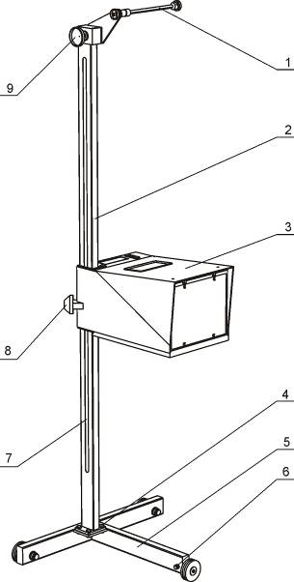
1 telescopic viewfinder orientation system, 2-front, 3-measuring unit, 4-bolt on the front platform trolley (4 pcs.) 5-trolley, 6-bolt clamp wheel, 7 - a ruler to determine the mounting height checked lights, 8-locking flywheel measuring unit, 9-screw visor
Figure 2 - Measuring the parameters of the beam. General view
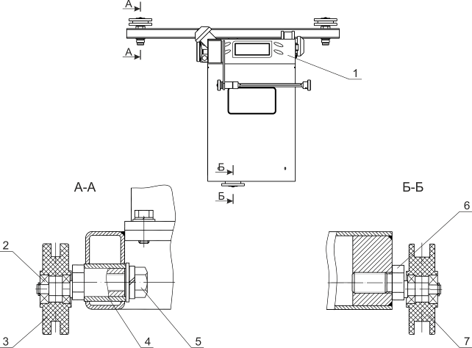

1-Control Panel. 2-bearing. 3-wheel and 4-axis. 5-bolt. 6-axis. 7-Wheel.
Figure 3 - Measuring the parameters of the beam. Top view
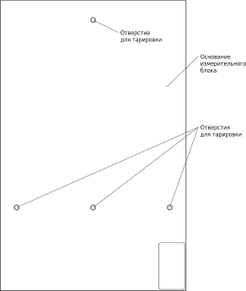 Figure 3a - The base measuring unit. Bottom view
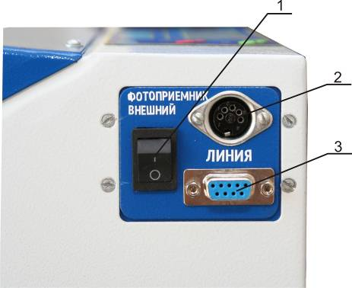
1 - Switch the external photocell 2 - Connection for external sensor indicators, 3 - connector line diagnostic monitoring
Figure 4 - The measuring unit. Side view
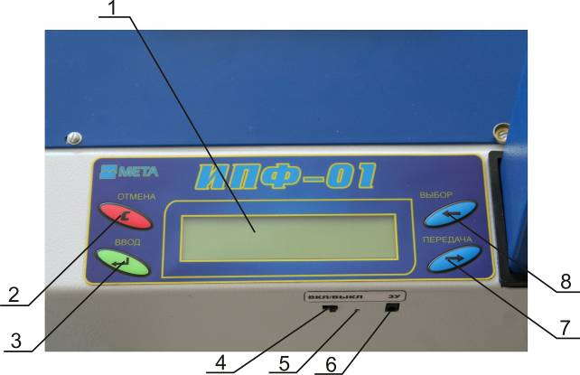

1 - Indicator 2 - "Cancel" button, 3 - button "enter" 4 - The power switch the device 5 - Charge Indicator 6 - Connector for charger, 7 - Button "transfer", 8 - button "SELECT" ;
Figure 5 - Control Panel
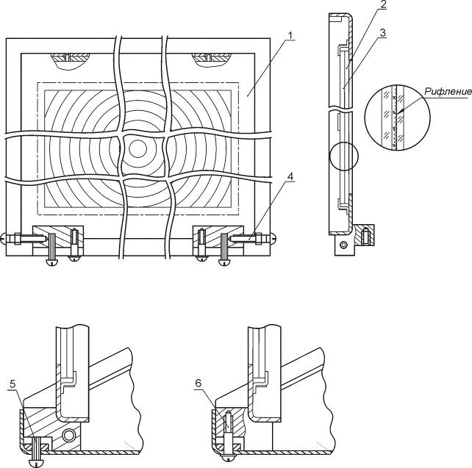

1 lens mount, 2-Glass, and 3-Fresnel lens, 4-regulating screw to align the center of the Fresnel lens from the optical center of the diagnosed fixture, 5-screw adjustment, 6-screw
Figure 6 - Lens, mounted with mounts and lens control

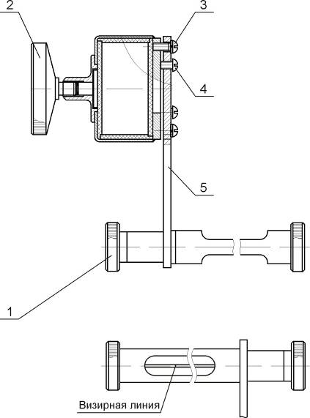

1 - Screw (flywheel) fixing the reticle rotation;
2 - Screw (flywheel) fixing vertical movement reticle;
3 - screw;
4 - adjustment screws;
5 - Bracket
Figure 7 - Viewfinder attitude control the device

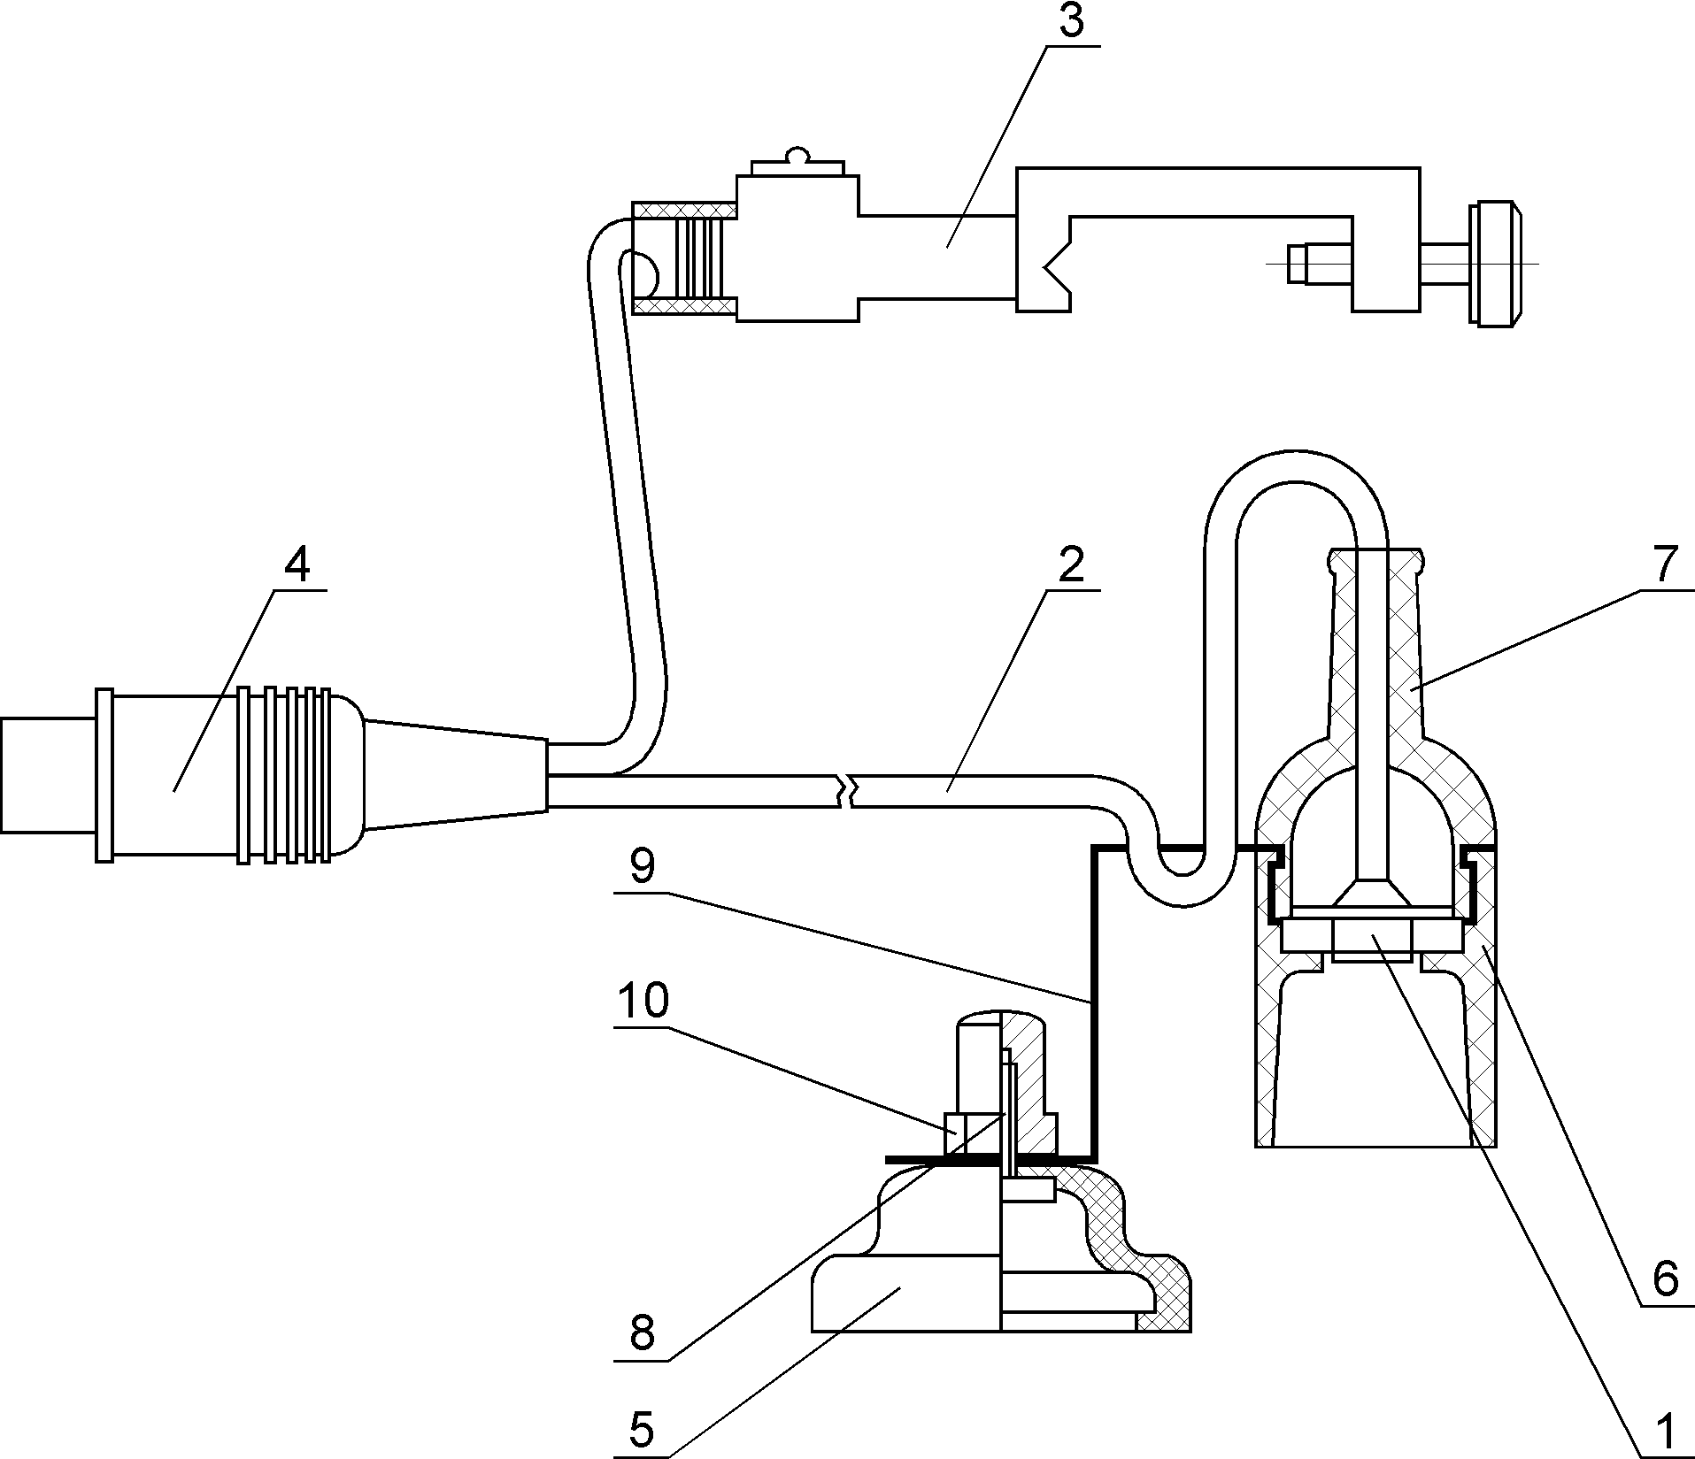

1 Plata photo detector 2-wiring 3-Sensor indicator, 4-connector to the measuring unit, 5-cap-sucker, 6-Case, 7-cover, 8-screw, 9-bracket, 10-Nut
Figure 8 - External Photocell

1.1.5 Labeling and sealing
1.1.5.1 Marking GOST 20790-82, and includes:
- The trade mark of the manufacturer;
- The code name;
- A sign of approval;
- Designation of technical terms;
- The serial number;
- The year of manufacture of the product.
1.1.5.2 Marking made ​​a manner ensuring accuracy and integrity during the whole period of the appliance. Marking and seal affixed in the locations provided in the drawings.
1.1.6 Packaging
1.1.6.1 the instrument and supporting documentation in the packaging, providing safety during transportation
2 Intended Use
2 .1 Operating Limits
Condition of the site is critical to the proper operation of the device. The site (optional horizontal - the supposed longitudinal slope up to 5 ° in the entire length of the base of the vehicle and the device) must be level. Permissible unevenness in the area of the installation tool (width of 1,8 m from the front of the body and length - 2.5 m along the front of the car body) should be no more than ± 1,0 mm, in an area of ​​the car is not more than 3 mm.
At the site (site location of the vehicle) can be potholes deeper than 10 mm and an area - no more than 5 mm2. Per 1 m2 should be no more than two of potholes. At the installation sites, the presence of potholes the device is not allowed. As these remarks meet the requirements for Category 1 road sections, such a platform can be found on the segment of the roadway or prepare the appropriate category according to the above requirements specifically.
WARNING: AREA luminous surfaces LIGHTS Checks shall not exceed 280 square centimeters
2.2 Preparing for use
2.2.1 On delivery device dismantled components. To prepare the device for operation assemble the device as shown in Figure 2. Initially fix the rack (Fig. 2) on a platform trolley with 4 bolts and set it on the measuring unit, fixing pre-position measuring unit flywheel locking (Fig. 2, item 8). Set at the front optical sight, securing it flywheel fixing vertical displacement (Fig. 2, position 9).
2.2.2 Hold the measuring unit housing bottom, turn the flywheel locking measuring unit counterclockwise several turns. After this test set should smoothly (without slip and seizure) to move the rack up and down (Fig. 2). Fix the position of the measuring unit in height by turning the flywheel locking the measuring unit on the stand.
If necessary, follow the steps on the adjustment of the instrument in accordance with the instructions in this guide p.3.1.2.2.
2.2.3 Check the correct operation of the measuring unit.
2.2.3.1 When charging unit from the vehicle electrical system via the cigarette lighter plug power cord supplied with the device to the power socket and the mating socket in your vehicle.
Charging the battery
WARNING: STRICTLY OBSERVE ORDER charger connection.
The device with power off connects the charger cable to the connector of the battery.
Connect the charger to a 220 V 50 Hz.
While charging, the charger LED lights red. Charge time about 8 hours.
Termination charge automatic. After charging, the LED is green.
Note - use device during charging. At the same time, the charge increases.
Automatic termination charge is only possible with the power off the device.
2.2.3.2 Turn on the device by setting the power switch (Fig. 5) to ON. The device delivers two short beeps and the display will read:
number of the device B
diagnostic network: XXX
where XXX - a value from 0 to 255, used in the operation of the device in the "technical control" (LTC).
Note - Network device number is stored in non-volatile memory and is set in the manufacture of seven.
If the appliance will not operate in the "technical control", click OK and then follow the steps to p.2.2.3.3.
When operating in the LTC can, if necessary, change the network number. If you press SELECT increasing the value of numbers, the Cancel button - decrease number value.
Work in the "technical control" provides both wired and wireless. Connecting the devices specified in the relevant manual for "Line of technical control."
After selecting the desired value, press ENTER.
2.2.3.3 The display shows:
NUMBER TC
0
SELECT button to select the digit corresponding to the digits of the number will be checked the car. Confirm your selection by pressing ENTER, the display shows the following figure. SELECT button to select a number, corresponding to the average number digits checked the car. Confirm your selection by pressing ENTER, the display shows the following figure. SELECT button to select a number, the least significant digit of the number inspected vehicle. Confirm your selection by pressing ENTER, the display will show which demonstrates the correctness of the device:
Measured modes
______
2.2.3.4 Turn off the device.
2.3 Installation of the device and its orientation relative to the vehicle
2.3.1 Preparation of the vehicle to the test
2.3.1.1 the vehicle on the ground to position the straight-ahead.
2.3.1.2 The pressure in the tires of the vehicle shall comply with the standards set out in the instructions to the vehicle.
2.3.1.3 The load on the vehicle shall be as specified in the instruction manual of the vehicle.
2.3.1.4 If there is an automatic adjustment range (step less or two-stage adjustment device), you should follow the manufacturer's instructions. Verified by the operation of external lights, problems can be solved.
2.3.2 Prepared to work to install the device in front of the diagnosed light device (lights, lights) of the vehicle.
2.3.3 Moving the test set on the counter, pick up the measuring unit to a height at which the center of the lens is the center of a car's headlights. Tolerance may be at altitude and in hand less than ± 3 cm distance from the lens to the headlights should be 30 ... 50 cm
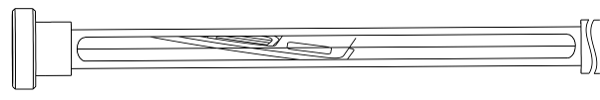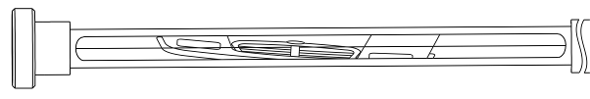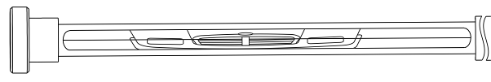2.3.4 The final orientation of the device relative to the vehicle, providing the installation of the direction of the vehicle, carried out on a symmetrical body points (edge ​​of the body, or the tops of the upper plane scatterers headlights, symmetric point hood, trunk, etc.) and performed with an optical viewfinder system orientation.
2.3.4.1 Loosen the screw visor (Fig. 7), turn the optical viewfinder so that it observed the front part of the car body (see Figure 9).
2.3.4.2 Rotate the measuring unit in conjunction with a reception in the horizontal plane, achieve a situation in which the orientation chosen for the body symmetric points will be observed on the line optical viewfinder. Secure the flywheel device, which weakens for orienting the device relative to the vehicle.
2.3.4.3 If the body of the car is strongly curved and does not allow viewing on symmetrical points, these points are projected onto the supporting surface plumb or other device. Then orientation produced by projections of symmetric points.
а
б
в

Figure 9 - The orientation of the device relative vehicle. Car image observed through the optical viewfinder unit:
a) and b) - if the wrong orientation, c) - with the right orientation.
2.4 Use of the device
2.4.1 Measuring the performance of headlamps
2.4.1.1Tehnology adjustable beam headlamps
Install the device in front of a car's headlights and run its orientation relative to the vehicle in accordance with the recommendations of Section 2.3.
On a ruler placed on a tripod device, determine the height of the lights tested. Flywheel rotation moves the screen (Figure 4) to set the value on a scale of 11 limb movements of the screen according to Table 2.
Table 2
Installation height checked lights, mm | Nominal angle of the light beam headlights |  | Value on the scale move the screen
 | угл. мин | %
till 600 | 34 | 1,00 | 10 (В)
600….700 | 45 | 1,30 | 13 (В)
700….800 | 52 | 1,50 | 15 (В)
800….900 | 60 | 1,76 | 17,6 (В)
900…1000 | 69 | 2,00 | 20 (В)
1000…1200 | 75 | 2,20 | 22 (В)
1200…1500 | 100 | 2,90 | 29 (В)
Turn on the headlight. Conduct a headlamp so that the left horizontal part of the cut-off line for passing beam coincident with the left part of the number "0" on the screen, and the right part of the sloping cut-off in this case must match the sloping line on the screen (Figure 10).
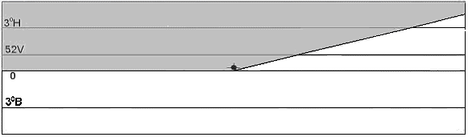
Figure 10 - The position of the cut on the display screen when the device is properly adjusted headlamp beam
2.4.1.2 Process control headlamps
Install the device in front of a car's headlights and to its orientation relative to the vehicle in accordance with the recommendations of Section 2.3.
Flywheel rotation move the screen (Figure 4) set to 10 (B) on the scale of the limb 11 moving screen.
Turn on the headlight. Conduct a headlamp so that the hole is a sensor on the screen was in the center of the light spot (11).
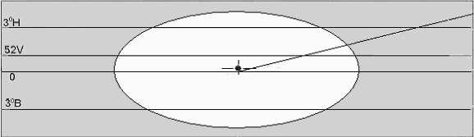
Figure 11 - The image on the display screen when the device is properly adjusted headlamp beam
2.4.1.3 Process control fog lamps
Install the device in front of a car's headlights and fog hold its orientation relative to the vehicle in accordance with the recommendations of Section 2.3.
Of the measuring range (Fig. 2, position 7), located on a tripod device, determine the height of the lights tested. Flywheel rotations move the screen to the desired value on the scale of the limb movements of the screen according to Table 3.
Table 3
Installation height checked fog, mm | Nominal angle of the light beam headlights |  | Value on the scale move the screen | drawing
 | угл. мин. | %
250....750 | 69 | 2,0 | 20 (В) | 13.а
750. ..1000 | 140 | 4,0 | 40. 3°В | 13.b
Activate and adjust the headlight. The control is a combination of the boundary of the light beam with the line "0" on the screen of the device, if the angle of the light beam headlights is 2% (Figure 12), or with the line "3 °" on the screen of the device, if the angle of the light beam headlights is 4% (ris.12b).
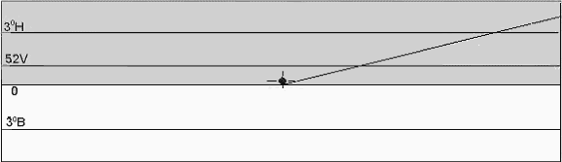
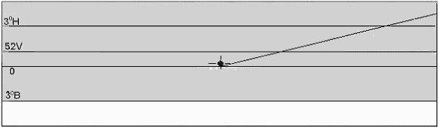
Figure 12 The position of the cut on the display screen when the device is properly adjusted fog lamp car
2.4.1.4 Measurement of the headlight beam in the direction of the optical axis of the headlamp
Before measurement of luminous intensity dipped beam headlights should be adjusted in accordance with paragraph "Technological adjustment beam headlamps."
The light intensity of each headlamp shall be as specified in Table 4.
Table 4
Type of lights | Light intensity lights in the direction of the optical axis of the headlamp  кд, no more  (Amended № 1 GOST R 51709-2001)
C ; CR | 800
HC; HCR; DC; DCR | 950
SELECT button to select Mode 1 - for the right headlight or mode 4 - the left headlight.
The display the device shows:
to the left or to the right headlight lights
MODE = 4 nearest left 34В |  | MODE = 1 nearest right 34В
х х х. х cd |  | х х х. х cd
Install the device in front of a car's headlights and to its orientation relative to the vehicle in accordance with the recommendations of Section 2.3.
Flywheel rotation move the screen set to 10 (V) on the scale of the limb movement screen.
Turn on the headlight beam. Press the ENTER button on the bottom line of the display the device will be the measured of luminous intensity headlights.
to the left or to the right headlight lights
MODE = 4 nearest left 34В |  | MODE = 1 nearest right 34В
х х х. х cd |  | х х х. х cd

where xxx.x - measured of luminous intensity dipped headlights in the dark zone (in the optical axis lights) in candelas.
After the reading stabilizes, you can exit from this mode.
To do this, press the Cancel button. The display will alternate message:
MODE = 4 nearest left 34В |  | MODE = 1 nearest right 34В
х х х. х cd |  | х х х. х cd
and

SAVE?

When working with the "line of technical control" to save the measured value in the memory by pressing the ENTER button, the display shows:
was measured mode 1 or mode 4 was measured
Measure mode:: |  | Measure mode:
1 - - - - - - - - - - - - - - - - |  | - - - 4 - - - - - - - - - - - - -

If you do not need to save the results, press button CANCEL, the display will read:
Measure mode::
- - - - - - - - - - - - - - - -
Press the ENTER button, the display will show
MODE = 1 nearest right 34В
х х х. х cd
If you need to repeat the measurements in this mode - press enter, otherwise the select button to choose the desired mode.
2.4.1.5 Measurement of the headlight beam in the direction of 52 'down from the left of the horizontal part of the cut-off
the light intensity of each headlamp shall be as specified in Table 5.
Table 5
Type of lights | Light intensity lights in the direction of 52 'down from the left side of the cut-in cd, not less  (Amended № 1 GOST R 51709-2001)
C ; CR | 1600
HC; HCR; DC; DCR | 2200
SELECT button to select mode 2 - measurement of luminous intensity right headlight or
Mode 5 - measurement of luminous intensity left headlight. The display the device shows:
to the left or to the right headlight lights
MODE = 5 nearest left 52В |  | MODE = 2 nearest right 52В
Depending on the height of the equipment are checked lights, hand wheel to move the screen 12 (Fig. 4) to set the value on a scale of 11 limb movements of the screen according to Table 6.

Table 6
Installation height checked lights, mm | Nominal angle of the light beam headlights |  | Value on the scale move the screen
 | угл. Мин | %
Till 600 | 34 | 1,00 | 10 (Н)
600….700 | 45 | 1,30 | 13 (Н)
700….800 | 52 | 1,50 | 15 (Н)
800….900 | 60 | 1,76 | 17 (Н)
900…1000 | 69 | 2,00 | 20 (Н)
1000…1200 | 75 | 2,20 | 22 (Н)
1200…1500 | 100 | 2,90 | 29 (Н)

Turn on the headlight beam. On the instrument left horizontal part of the cut-off of the passing beam must coincide with the left side of the line "52V" on the screen (Figure 13).
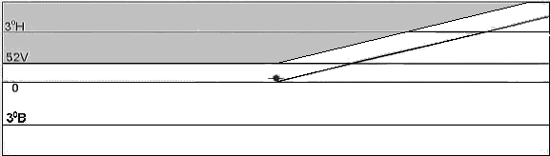
Figure 13 - Position the cut-off line for passing beam
Press the ENTER button on the bottom line of the display the device will be the measured of luminous intensity headlights.
to the left or to the right headlight lights
MODE = 5 nearest left 52В |  | MODE = 2 nearest right 52В
where xxx.x - measured of luminous intensity low beam light in the area (52 'below the cut-off), the candles.
After the reading stabilizes, you can exit from this mode.
To do this, press the Cancel button. The display will alternate message:

MODE = 5 nearest left 52В | or | MODE = 2 nearest right 52В

SAVE?
and
When working with the "line of technical control" to save the measured value in the memory by pressing the ENTER button, the display shows:
was measured mode 2 or mode was measured 5
Measure mode:: |  | Measure mode:
-2 - - - - - - - - - - - - - - - |  | - - - -5 - - - - - - - - - - - -

If you do not need to save the results, press button CANCEL, the display will read:

Measure mode::
- - - - - - - - - - - - - - - -
Press the ENTER button, the display will show

MODE = 2 nearest right 52В

If you need to repeat the measurements in this mode - press enter, otherwise the selection button select further measurements.
2.4.1.6 Measurement of the beam headlamps
before the force sensing beam headlamps headlights should be adjusted in accordance with paragraph "Technological adjustment headlamps."
Luminous intensity of headlamps type R, HR, CR, HCR, DR, DCR, located on one side of the PBX in the "distant" light should be not less than 10,000 candela, and the total of the of luminous intensity of the headlights of all types should not be more 225000 cd (Amended № 1 GOST R 51709-2001)
SELECT button to select Mode 3 - measurement of luminous intensity right headlight or Mode 6 - Measurement of luminous intensity left headlight.
The display the device shows:
to the left or to the right headlight lights
Mode = 6 distant left |  | РЕЖ. = 3 distant right
Install the device in front of a car's headlights and to its orientation relative to the vehicle in accordance with the recommendations of Section 2.3.
Flywheel rotation move the screen set to 10 (B) on the scale of the limb movement screen.
Turn on the headlight beam. The hole photo detector on the instrument must be in the center of the light spot (Fig. 14).
Figure 14 - The position of the beam cut-off beam
Press the ENTER button, the display the device will display:
to the left to the right headlight lights
Mode = 6 distant left | or | РЕЖ. = 3 distant right
xxx.x cd |  | xxx.x cd
where xxx.x - measured of luminous intensity headlamp light in candelas
After the reading stabilizes, you can exit from this mode.
To do this, press the Cancel button. The display will alternate between posts
Mode = 6 distant left | or | РЕЖ. = 3 distant right
xxx.x cd |  | xxx.x cd

SAVE?
and

When working with the "line of technical control" to save the measured value in the memory by pressing the ENTER button, the display shows:
Mode 3 has been measured or measured the mode 6
Measure mode:: |  | Measure mode:
- -3 - - - - - - - - - - - - - - |  | - - - - -6 - - - - - - - - - - -

If you do not need to save the results, press button CANCEL, the display will show

Measure mode::
- - - - - - - - - - - - - - - -
Press the ENTER button, the display will show

Mode: =3 distant right

If you need to repeat the measurements in this mode - press enter, otherwise the selection button select further measurements.
2.4.1.7 Measuring the of luminous intensity fog lamps
Before measurement of luminous intensity fog lamps lights should be adjusted in accordance with paragraph "Technological adjustment fog lamps."
Power light fog light in the direction of 3 º up the position of the cut-off should be no more than 625 cd (Amended № 1 GOST R 51709-2001).
SELECT button to select Mode 7 - measurement of luminous intensity right fog lamp in a dark area (3 ° up to the cut-off) or Mode 9 - also for the left headlight.
The display the device shows:
to the left or to the right headlight lights
РЕЖ. = 9 ПРТ. ЛВ. 3В |  | РЕЖ. = 7 ПРТ. ПР. 3В

Install the device in front of a car's headlights and fog hold its orientation relative to the vehicle in accordance with the recommendations of Section 2.3.
Turn on the headlight. Flywheel rotations move the screen to combine the cut-off of the light beam with the line "3 °" on the screen of the device (Fig. 15).
Figure 15 - the cut-off position of the light beam fog lamps
Press the ENTER button, the display the device will display:
РЕЖ. = 9 ПРТ. ПР. 3В |  | РЕЖ. = 7 ПРТ. ПР. 3В
х х х. х cd |  | х х х. х cd

where xxx.x - measured of luminous intensity right fog lamp in a dark area (3 ° up to the cut-off), the candles.
After the reading stabilizes, you can exit from this mode.
To do this, press the Cancel button. The display will alternate message:
mode = 9 ПРТ. ПР. 3В |  | mode = 7 ПРТ. ПР. 3В
х х х. х cd | или | х х х. х cd

и
save?
When working with the "line of technical control" to save the measured value in the memory by pressing the ENTER button, the display shows:
mode was measured 7 or 9 was measured mode
measured mode: |  | measured mode:
- - - - - - 7 - - - - - - - - - - |  | - - - - - - - - 9 - - - - - - - -
If you do not need to save the results, press button CANCEL, the display will read:

measured mode:
- - - - - - - - - - - - - - - - -
Press the ENTER button, the display will show:
РЕЖ. = 7 ПРТ. ПР. 3В
If you need to repeat the measurements in this mode - press enter, otherwise the selection button select further measurements.
2.4.2 Measurement of the glimpses of indicator lamps
The repetition frequency of flashes to be in the range of (90 ± 30) flashes per minute or (1,5 ± 0,5) Hz (Amended № 1 GOST R 51709-2001).
SELECT button to select the mode - measurement of the glimpses of indicator lamps. The display the device shows:

РЕЖ. = В ПРОБЛЕСК.
Connect to an external device connector photo detector. External light detector set to indicator lamp vehicle with the cap-sucker.
Sensor on the turn signal lever to set the direction indicators, so that the limit switch button is mounted on a swing arm, touched the lever of the direction indicators (fig. 9, 16).
After selecting the device press ENTER. The display shows:
РЕЖ. = В Т = * . * с
F = * . * Гц К = * * %
If you enter the external connector to a sensor was not connected to the device, the display will read:
НЕТ ВЫНОСНОГО
ПРИЕМНИКА СВЕТА!
Connect to an external device connector photo detector, the display will read:
РЕЖ. = В Т = * . * с
F = * . * Гц К = * * %
The inclusion of the turn signal lever to exercise influence on the back of the bracket (Figure 16) with a force sensor permits operation buttons. After a time in the delay of the direction indicators, the display the device will be the measured performance indicators:
T - time elapsed before the first glimpse of the moment when
F - frequency of the flashes
K - the ratio of time burning lamp to cycle time.
F and K are updated at regular intervals to fold repetition rate flashes.
After the reading stabilizes, you can exit from this mode.
To do this, press the CANCEL button on the device and then turn the turn signal lever to turn the car in the off position. The display will alternate between the messages (for example):
РЕЖ. = В Т = 0.4 с
F = 1.4 Гц К = 63 %
and

save?
If necessary, save the measured values ​​in the memory by pressing the ENTER button, otherwise click CANCEL
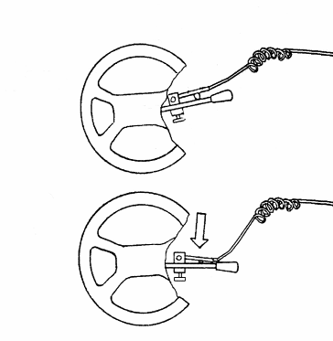

Figure 16 - Installation of the sensor of the direction indicators
on the steering wheel and the direction indicators
2.4.3 The measured value transmission characteristics in the "line of technical control"
The measured value transmission line technical control is possible if the measurement is at least one characteristic (measured stored in memory.) The transfer is made when the display the device is present a message such as:
ИЗМЕРЕНЫ РЕЖИМЫ:
--3--------
Press the transfer button, the display will show
ПЕРЕДАТЬ В ПК?
Press enter data in a line, or click Cancel to exit the data transfer. If the line is faulty or not connected to the device, or a computer program running the diagnosis, the display the device will display:
НЕТ CЕТИ!
ПОВТОРИТЬ?
After a successful transmission line appears on the indicator
НОМЕР ТС
0
The operator can start scanning the next car.
3 MAINTENANCE
3.1 Maintenance of the device
3.1.1 Safety
3.1.1.1 to work with the device allowed persons who are familiar with these operating instructions
3.1.2 Maintenance Procedures
3.1.2.1 the device does not require frequent maintenance work and special care. In the operation should be kept clean.
Before you use the instrument is recommended to check mounting orientation system, smooth movement and accuracy of the measuring unit fixing the tripod in position.
Unacceptable accumulation of dust on the lens of Fresnel, as this changes the characteristics that affect the measurement of light intensity. Dust extraction should be done with a soft brush or a dry brush. It is necessary to make sure that the lens is not scratched with abrasive particles present in the dust. After the shift to the measuring unit, wear cover of the unit.
It is also necessary to check the adjustment of the instrument and performance measuring unit.
3.1.2.2 Aligning the device
aligning the device periodically, at least once in three months.
When adjusting the device, make sure:
- In parallel to the line reticle lines marking the screen;
- In the perpendicular plane of the lens and the screen relative to the base measuring unit;
- In parallel to the base unit measuring device installation site.
1) Check the parallel orientation of the reticle and the horizontal line marking the screen
Checking parallelism reticle orientation system and a horizontal line marking the screen by implication, parallel elements, device design, which obviously parallel horizontal line marking the screen (Figure 17). In this case, the upper horizontal section of the device, which you must install the viewer in the position at which the line of the reticle is aligned with the edge of the horizontal part of the top cover. The provisions of the two lines should be the same. The discrepancy between the lines to remove the screws alignment and mounting of the orientation (Fig. 7).
2) Verification of parallel planes screen and lens
Testing parallel to the screen and the lens by means of a compass with depth as follows:
- Alternately insert the depth gauge into the hole for calibration (Fig. 3) based on the gauge block. The size of the base to the center should be the same. Limb must be the same mark on the glass: a mark - 10V;
- Tighten the screws limb.
The size of the base to the center should be the same. Limb must be the same mark on the glass: a mark - 10V;
- Tighten the screws limb;
3) Check that the measuring unit parallel to the ground regarding the verified sites is carried out by the level placed on the base (on the holes for calibration), and adjust the position of the wheels (Fig. 2, position 10) located on the trolley by means of screws (Fig. 2, item 5).
Figure 17 - Indirect testing a parallel orientation of the reticle and the horizontal line marking the screen
3.2 Maintenance
3.2.1 Typical faults and troubleshooting
Typical faults and remedies are given in Table 7.

Table 7
name of fault | probable cause | Remedy
1 | 2 | 3
After turning on the device is not lit | Cable break power-up failure | Check the power cable, use an ohmmeter to check the charger
After switching on the display shows:  OFF. Remote.  RECEIVER LIGHT! | Connect an external photocell light | Disconnect from the device connector of the external photocell light
The display device (Mode B) message:  NO Outriggers  Light receivers! | Disconnected connector or connector pins contaminated external photocell light | If necessary, clean the contacts of external photocell light socket, connect it to the device
The display the device message:  NO NETWORK!  REPEAT? | a) Disconnect the connector or connector pins contaminated diagnostic line  b) The computer program running  diagnostic monitoring  c) Faulty cable connection | a) Clean the connector pins if necessary diagnostic line, press the ENTER button on the device  b) Run the program on the computer  diagnosis, press the ENTER button on the device  c) Replace the cable connection
No parallel to the screen and the lens | Changing the position of the relative position of adjustment screw base, lens and screen | Set perpendicular to the plane base lens and screen  using instrumental gon turn screws resting on a frame and lens housing.
The absence of parallel optical viewfinder system orientation horizontal lines on the screen | Changing the position of the screws on the bracket adjustment viewfinder and adjusting the screen | Set parallel, shifting adjustment screws to align the optical sight and a horizontal line marking the screen
The lack of parallelism of the base the device and the installed site | Changing the position of the adjusting screws on the trolley, wheel offset | establish parallel  Grounds Bracket moving wheels on the truck with the adjustment and fixing screws
Loose flywheel rotation move screen | Wear collets bearing axis hand wheel | Loosen the screws on the axis of the limb, draw in the center screw on the flywheel, screw the limb
The discrepancy between the actual position of the screen with a mark on the limb | Angular displacement on the axis of the limb, the limb Loose | Verify that the center of the screen to the center of the lens. To do this, insert into the hole for calibration (Fig. 3) based on the measuring unit depth gauge caliper. The size of the base to the center should be the same. Limb must be the same mark on the glass: a mark - 10V. Tighten the screws limb

4 TRANSPORTATION
4.1 Devices in the manufacturer's package can be transported by any means of private transport.
4.2 The conditions of transportation should comply with the conditions of storage 7 GOST 15150-69.
5 Storage
5.1 the instrument shall be retained by the manufacturer and the consumer
enclosed spaces in accordance with the storage group 1
GOST 15150-69 with limited low temperature down to minus 30 ° C.

Appendix A

Measuring parameters of light of headlights
VEHICLES IAP-01
verification procedure
MP Tinto 45-2012

Moscow
2012

This calibration procedure applies to measuring parameters headlights of vehicles IAP-01 and establishes a methodology for their initial and periodic calibration.
The interval between periodic check is 1 year.
1. Operation verification
during verification must be carried out the operations specified in Table 1.
Table1
 | Stage of verification | Item number of the document  for verification
1 | visual inspection | 7.1
2 | Testing, performance testing of functional modes | 7.2
3 | The definition of the metrological characteristics | 7.3
3.1 | Determination of error of zero meter installation in the vertical plane | 7.3.1
3.2 | Determination of error of zero meter installation in the horizontal plane | 7.3.2
3.3 | Determination of measurement error angles of inclination cut-beam lights in a vertical plane | 7.3.3
3.4 | Determination of measurement error repetition frequency of light flashes indicator lamps | 7.3.4
3.5 | Determination of measurement uncertainty of luminous intensity headlights | 7.3.5

2. Verification means
during verification shall apply the standards and resources that are listed in Table 2.
Table 2
№  п/п | Name and type of  checking means | The main technical  features
 | theodolite | 4T30P, measurement error of ± 30 ², GOST 10529-96
 | electronic total station | Sokkia Topcon 650RX, the measurement error is not more than 6 "GOST R 51774-2001
 | calibration plate | (1600 × 1000) mm, Cl 1, GOST 10905-86
 | Steel measuring tape | (0 ÷ 3000) mm, cl. 3, GOST 7502-89
 | stopwatch | Cl. accuracy of 1.0, TU 25 1894 003-90
 | cargo | Set (10mg-5 kg) M1 GOST 7328-2001
 | Reference telecentric illuminator IS-2 | TU 44 8000-148-2129868-2006
 | light source | Headlight category R2, HS1, or SB 41.1-99 GOST R, GOST R 41.5-99, 41.8-99 GOST, GOST R 41.20-99, GOST R 41.31-99
 | illuminometer | "TKA-Lux / Standard" (1 ÷ 50000) lx limit basic relative error of ± 2% light

Allowed to use other means of verification to ensure the definition of the metrological characteristics with accuracy to meet the requirements of this test procedure.
3. Requirements for qualification verification officers.
To perform the calibration allowed a person who studied the operational documents for measuring parameters headlights of vehicles IAP-01, with sufficient knowledge and experience with them and certified as verifications authority of the State metrological service.
4. Safety requirements.
4.1. Before the calibration should be considered a technical description and operating instructions per test measuring parameters headlights of vehicles IAP-01 and instruments used for verification.
4.2. Before the calibration to be performed the following work:
- All parts of the world measuring the parameters of motor vehicle headlamps IAP-01 and means of verification must be free of dust and dirt;
- Measuring parameters headlights of vehicles IAP-01 must be securely attached to the floor with no slope and roughness, adjusting elements movable optical camera meter should be properly secured.
5. Conditions for verification.
During verification subject to the following standard conditions of measurement:
- Ambient temperature, ° C 20 ± 5;
- Relative humidity,% max (60 ± 20);
- Atmospheric pressure, кПа (mm Hg. Article.) 84,0 ÷ 106,7 (630 .. 800).
6. Preparation for verification.
6.1 Before the operation verification should be familiar with the manual M 048.000.00.00 RE.
6.2 Prepare a meter to work in accordance with section 2.2 Manuals M 048.000.00.00 RE.
7. Verification procedure.
7.1. Visual inspection
Physical examination is checked:
- The lack of apparent violations of coatings meter;
- Code number of the meter number on the passport.
- Completeness of the meter.
Must be established:
- Inscription on the marking plate meters, defining the name of the meter and trade mark - the manufacturer, the sign of approval, designation, serial number and year of the meter.
7.2. Testing, performance testing of functional modes.
When testing must have the appropriate measuring parameters headlights of vehicles IAP-01 with the following requirements:
7.2.1. Properly locked optical camera at the front to check a meter on the top surface of the chamber measuring a mass of 2 kg.
The meter shall be deemed satisfactory if the optical camera remains stationary relative to stand for 5 minutes.
7.2.2. Screen placed in the optical measuring cell should move smoothly without jerks and should not spontaneously change their position.
7.2.3. Range of movement of the optical camera meter is checked by measurement of the center of the optical camera lens at the top and bottom using a measuring tape with the floor. The meter shall be deemed satisfactory if the measured distances differ from those contained in the technical data for no more than 5 mm.
7.2.4. Markup Validation control screen. This procedure for measuring instruments, mechanical scale in the following sequence:
- Measuring parameters headlights of vehicles ИПФ-01 installed horizontally in accordance with the manuals on M 048.000.00.00
- Remove the top cover of the optical parameters of the camera meter headlights of vehicles ИПФ-01;
- In case of a lack of natural light for measurement, highlight the scale of the optical parameters of light gauge motor vehicle headlamps ИПФ-01 from a light source such as a flashlight;
- Set coaxially (± 30 mm) theodolite at 100 ÷ 300 mm from the lens optical camera meter parameters headlights of vehicles ИПФ-01;
- To put crosshairs on a horizontal line theodolite optical scale screen with his left hand;
Measuring parameters headlights of vehicles ИПФ-01 is considered to be satisfactory if you move the crosshair reticle theodolite from the left end of the horizontal line of the optical scale of the screen to the right end of the line, the center crosshairs not move more than the thickness of the horizontal line of the optical scale screen.
For meters with electronic scale, this procedure is performed in conjunction with a zero error checking settings, section 7.3.1 of this method. In this case, the evidence on the scale measuring the vertical angle of the laser beam while moving the instrument from the left to the right edge of the screen should not be greater than the measurement error of vertical angle in accordance with the technical specifications of the meter.
7.3. The definition of the metrological characteristics
7.3.1. Determination of error of zero meter installation in the vertical plane
7.3.1.1. Zero error setting meter parameters headlights of vehicles IAP-01 in the vertical plane defined by the optical or electronic meter scale using a theodolite or total station in the following sequence:
- Set coaxially (± 30 mm) theodolite (total station) at (100 ÷ 300) mm from the lens optical camera meter parameters headlights of vehicles ИПФ-01;
- Set the theodolite (total station) and the optical parameters of the camera meter headlights of vehicles ИПФ-01 in the vertical plane of the bubble level;
- To bring the telescope theodolite (instrument) on the screen measuring parameters headlights of vehicles ИПФ-01. Handle move the screen to move the meter on the screen reading "0". For e-point scale of "0" is set in the calibration software meter;
- To bring the telescope theodolite (crosshairs) on a horizontal line screen measuring parameters headlights of vehicles ИПФ-01 in the central part and take readings on the vertical limb theodolite φ0. If the meter is used in electronic scale vertical angles, counting at "0" is checked by means of a laser beam instrument;
- Zero error setting meter parameters headlights of vehicles will be calculated by the formula:
φ₀
Should perform at least five measurements in determining the accuracy of zero setting meter parameters headlights of vehicles ИПФ-01 and the average value taken as the final result. The obtained values ​​of the error zero installation meter parameters headlights of vehicles ИПФ-01 in the vertical plane in the minutes are not recorded.
The maximum permissible errors zero installation meter parameters headlights of vehicles in the vertical plane Δ 1 shall not exceed the value of 0.1%;
7.3.2. Determination of error of zero meter installation options headlights of vehicles ИПФ-01 in the horizontal plane.
Zero error installing the meter in the horizontal plane is determined by theodolite (instrument) in the following sequence:
- Put on a plate meter calibration parameters headlights of vehicles IAP-01 and total station theodolite or horizontally aligned using the optical viewfinder (mirror, slit or laser) measuring parameters headlights of vehicles ИПФ-01 and using the mark up, put on a plate calibration (Fig. 1). Theodolite with installed at a distance H = (100 ÷ 300) mm from the lens optical camera meter parameters headlights of vehicles IAP-01;

1. Theodolite (total station)
2. Telescope theodolite (instrument)
3. calibration plate
4. Line with the special markup (L1 = L2)
5. Optical camera meter
6. Display Meter with scale
7. telescopic viewfinder gauge
Figure 1
- Set the theodolite (total station) and the optical parameters of the camera meter headlights of vehicles IAP-01 in the horizontal plane of the bubble level;
- Crosshairs telescope theodolite to coincide with crosshair marked on a scale measuring the parameters of the screen headlights of vehicles IAP-01 in the zero point. To gauge the electronic scale, the measured value on the scale measuring instrument from the laser beam must be zero with an error permitted in accordance with the technical specifications of the selected modified meter;
- Zero error setting meter parameters headlights of vehicles IAP-01 in the horizontal plane Δ2 [... '] will be calculated by the formula:
φ₀,
where: φ0 [... '] - measured on the horizontal scale theodolite crosshairs deviation caused by the scale of the meter screen at the zero point (as indicated by the zero point of the instrument for measuring instruments with an electronic scale) from the center line (special markings on the surface plate.)
Should perform at least five measurements in determining the accuracy of zero setting meter parameters headlights of vehicles IAP-01 and the average value taken as the final result.
The obtained values ​​of the error zero installation meter parameters headlights of vehicles IAP-01 in the horizontal plane in the minutes are not recorded.
The maximum permissible errors zero installation meter parameters headlights of vehicles IAP-01 in the horizontal plane Δ 2 not to exceed 0 ± ° 30 '.
7.3.3. Determination of measurement error angles of inclination cut-beam headlights in the vertical plane.
When tested, proceed as follows:
- Set coaxially (± 30 mm) theodolite (total station) at (100 ÷ 300) mm from the lens optical camera meter parameters headlights of vehicles IAP-01;
- Set the theodolite (total station) in the horizontal plane, the bubble level;
- To bring the telescope theodolite (instrument) on the screen measuring parameters headlights of vehicles IAP-01. To gauge the scale of the optical lever move screen measuring parameters headlights of vehicles IAP-01 to move the screen to count down to "0";
- To bring the telescope theodolite on a horizontal line measuring the parameters of the optical screen headlights of vehicles IAP-01 in the central part and take readings on the vertical limb ψdeystv theodolite. To gauge the electronic scale readings are taken from measurements of the laser spot meter scale electronic instrument;
- Similarly to take readings on the vertical limb theodolite (instrument) for all values ​​of the digitized on a scale of reference moving screen measuring parameters headlights of vehicles IAP-01. For meters with an electronic scale to perform measurements at least five points of measurement range;
- Measurement error Δ3 [... '] is given by:
Δ3 = ψdeystv - ψizm
ψizm - determine from Table 3;
ψdeystv-count on the vertical limb theodolite (total station).
Table 3
The digitized values ​​of the coordinate measuring scale displacement meter screen (reading e scale) | The angle of the upper cut-off  beam headlamp beam
0% | 0º 00' (00 мм/10 м)
1% | 34,4' (100 мм/10 м)
2% | 1º 09' (200 мм/10 м)
3% | 1º 43' (300 мм/10 м)
4% | 2º 18' (400 мм/10 м)

In the calculation of the measurement error for the value of Δ 3 should be performed at each of at least five measurements, calculate the mean value and for the final results Δ 3 to take the greatest value. All measurements recorded in the minutes.
Limits of measurement error angles of inclination cut-beam headlamps in a vertical plane Δ3 shall not exceed 0.1%;
7.3.4. Determination of measurement error repetition frequency of light flashes indicator lamps.
7.3.4.1. Make connections according to the diagram shown in Figure 1
Appendix A. To verify-meter jack to connect external light receiver and transmitter of the direction indicators.
Install remote receiver that comes with the light meter in close proximity with power indicator IS-2. Turn dial to the setting current regulated power supply to minimum by turning counter-clockwise until it stops. MODE button to set the frequency of these flashes of 1.0 Hz, in accordance with the instruction manual on IT-2. Lamp rear light should turn on and flash at set on the indicator stabilized voltage source IT-2.
7.3.4.2. Enable verify-meter in the "B".
Press the sensor of the direction indicators. After the establishment of the display under test meter reading is stable readings.
Five times to measure and record them.
Calculate the average meter readings for the specified value flashing frequency indicator.
Repeat the measurement for the repetition frequency of 1.5 Hz flashes and 2.0 Hz.
Click the Cancel button on the meter and exit the "B" without saving the memory meter in accordance with the operating manual p.2.4.6 M 048.000.00.00 RE.
7.3.4.3. For each frequency flashing indicator to calculate the value of the absolute error by the following formula
where: ΔF - absolute error of measurement repetition frequency of flashes, Hz
Fizm - the average measured value of the repetition frequency of flashes, Hz
Fgen - the value of the repetition frequency of flashes on the testimony of IT-2 Hz
7.3.4.4. The maximum value of the absolute error of measurement repetition rate of flashes should not exceed ± 0,1 Hz.
7.3.5. Determination of the relative error of measurement of light intensity.
7.3.5.1. Determination of the relative error of measurement of luminous intensity using standard telecentric illuminator IS-2.
- Collect circuit verification in accordance with Figure 1 of Appendix A.
- Check your instrument and the power of the reference telecentric lighting fixture IS-2 must be installed on the same horizontal surface, ensuring their mutual alignment in the horizontal and vertical planes.
The distance L is selected from the range of 300 ... 500 mm. Visor should be set so that the surface on which the marking sight, facing the lamp lighting unit.
- Set Check your instrument into position and turn it on.
- Set the controller for setting the current regulated power supply IS-2 to the minimum turning them all the way counterclockwise.
- Set the switch network at a regulated power supply to the on position "1".
- Following the methodology described in the manual on IT-2, five times Check your instrument to measure light intensity for the five certified values ​​of intensity.
- Calculate the relative error of measurement of luminous intensity for each set value of intensity as follows:
where Iizm - Check your instrument measured luminous intensity, cd;
Iet - certified values ​​of intensity, light candles (see table checking passports IS-2);
The maximum value of the relative error δ the device must not exceed ± 15%.
7.3.5.2. Determination of the relative error of measurement of luminous intensity with the use of headlights and light meters.
- Set the reference light source (lamp category R2, HS1 or headlamp type SB) l oporn distance = 10 m from the screen, which is located perpendicular to the optical axis of the installed lights. Connect the lamp with a standard plug and wire diameter, corresponding to the selected power lights, to a regulated DC power supply. During verification under this methodology lamp shall be fixed by each of the following measurement modes;
- Set the sensor reference photo detector luxmeter in the light beam spot lights close to the back of the screen;
- Moving the sensor reference photo detector luxmeter on the screen plane, find the maximum value of the reading light, recorded by reference luxmeter. Write the value of the reference light from the scale luxmeter E deystv (lux) in the record;
- To calculate the intensities of the reference source I deystv (cd) in the selected measuring point using the formula:
I_{действ}= Е_{действ}× (l_{опорн})²
- The value I deystv (cd) to put on record;
- Set the measuring parameters headlights of vehicles IAP-01 in accordance with the instructions on distance (0,3 ÷ 0,4) m of standard headlamp. Measuring parameters headlights of vehicles IAP-01 must be oriented along the optical axis of the reference lights. A measurement of intensity by measuring the parameters of the light motor vehicle headlamps IAP-01. Testimony, the intensities in the display meter I izm put on record;
- Switch the lights work - the reference light source ("Dipped", "Distant Light") and adjusting the power supply voltage in the range (11 ÷ 13,5) in, measure light intensity of at least five points of the declared parameters for the meter headlights of vehicles IAP-01 measuring range of light intensity.
- If all the measurements on the item method to ensure that a set of optical axes geometry lights (reference light source) and a light receiver meter parameters headlights of vehicles IAP-01, did not change.
In each selected point of the measurement range to hold at least five measurements and calculate the arithmetic mean values ​​of these measurements. All measurements recorded in the minutes.
- The relative error of measurement of luminous intensity range in each of the tested
points of measurement range calculated by the formula:
where: I izm - indication of luminous intensity on the LCD screen measuring parameters headlights of vehicles IAP-01, cd;
I deystv - the estimated value of luminous intensity of the reference source, measured luxmeter-meter, cd.
For the final result of measurement error to the greatest of luminous intensity
the resulting value of δ for all the results of calculations.
Limits of relative error of measurement of luminous intensity δ should
exceed the value of ± 15%.
8. Documenting the results of verification
8.1. The results of verification in the protocol, drawn up in the summary table of the results of verification for each item in Section 7 of this test procedure, indicating the limit of numerical values ​​of measurements and their evaluation as compared to the demand.
8.2. If positive meter calibration parameters headlights of vehicles IAP-01 is recognized as fit for use and it is given a certificate of verification prescribed form showing the actual results of the determination of the metrological characteristics.
8.3. With negative results verification, measuring parameters headlights of vehicles IAP-01 as unfit for use and it issued a notice of unfitness of the prescribed form, specifying the reasons.

chief Specialist
LLC "TestInTeh"__________________________________________ ____________ V. Abramov

Appendix A1
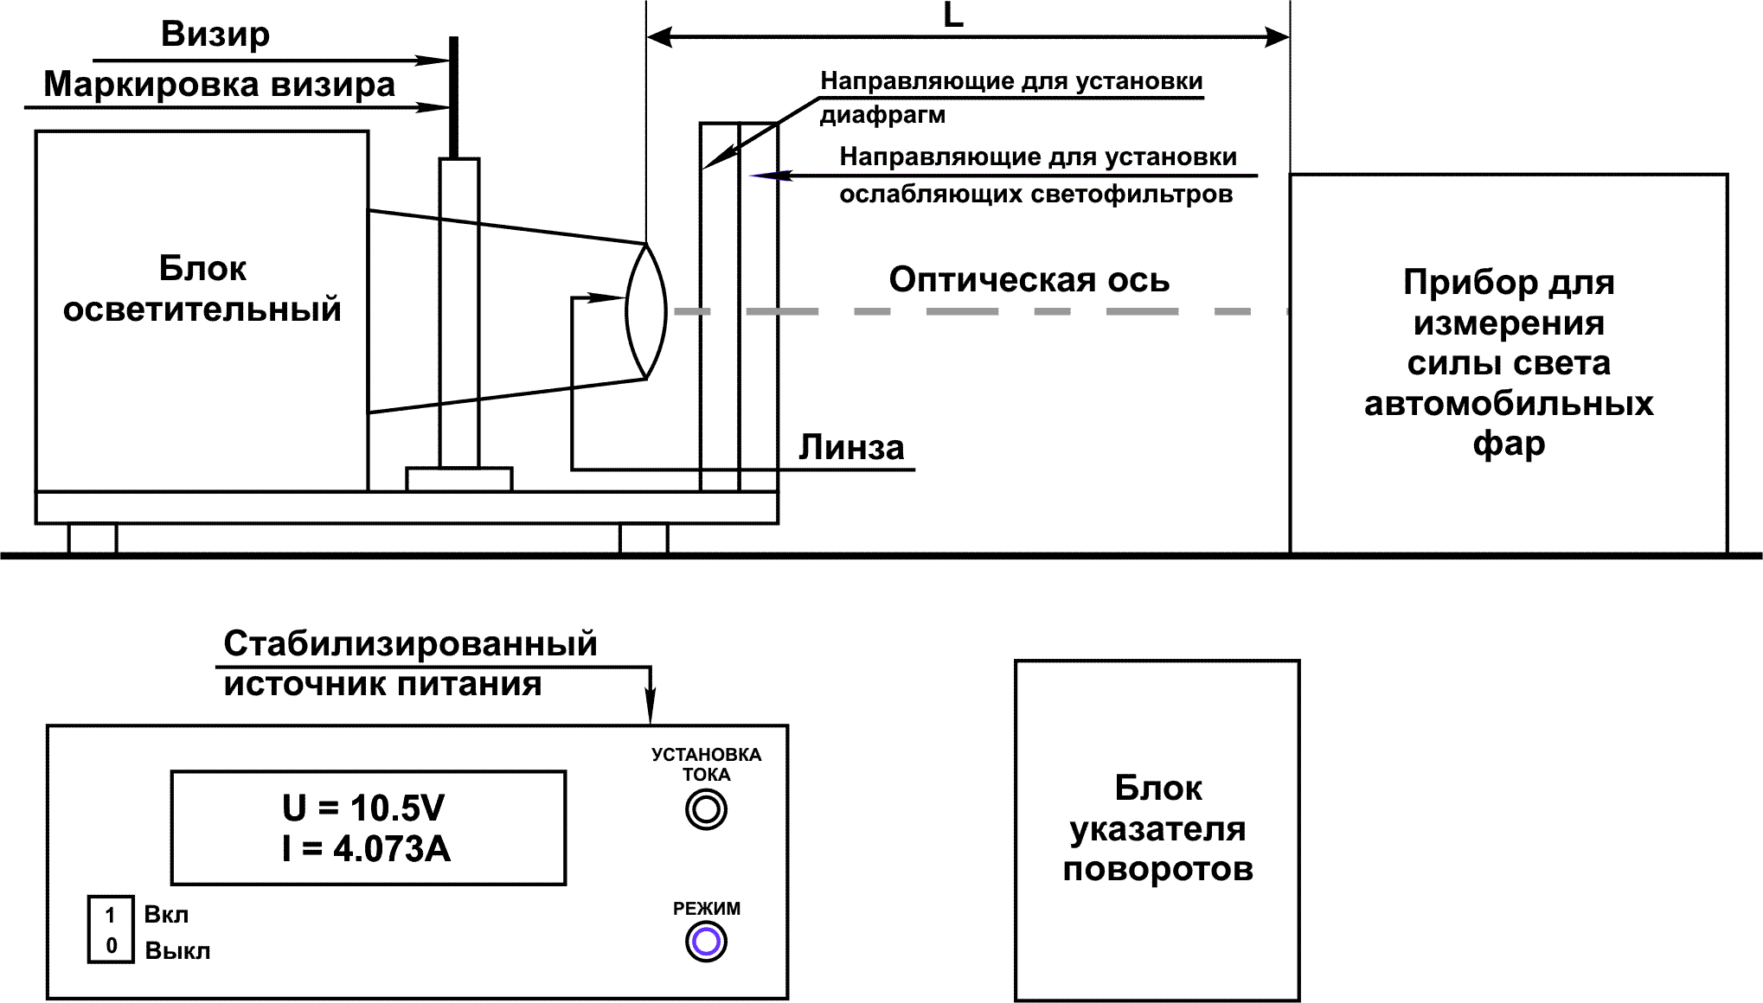
Figure 1. Block diagram of the measurement error determination of luminous intensity and repetition rate of flashes the turn signal with the reference telecentric illuminator "IT-2"

